**SQA Project Report**

**Team Name: TEAM3 (Megan Crews, Aneesh Akella, & Will Thompson)**

**4a. Git Hooks (Aneesh Akella)**

**4b. Fuzzing (Megan Crews)**

The project outline required us to create a fuzz.py file that automatically fuzzed 5 python methods of our choice within the zip file given in the instructions. I fuzzed 5 methods of my choice and learned from each of them that it is important to test each fuzzing method with multiple inputs as each input can lead to a different conclusion. Fuzzing helps you figure out security problems within your code, but also if testing enough inputs, you can get a good grasp of which inputs give you the right outputs. Below are screenshots of the output from running “python fuzz.py”.

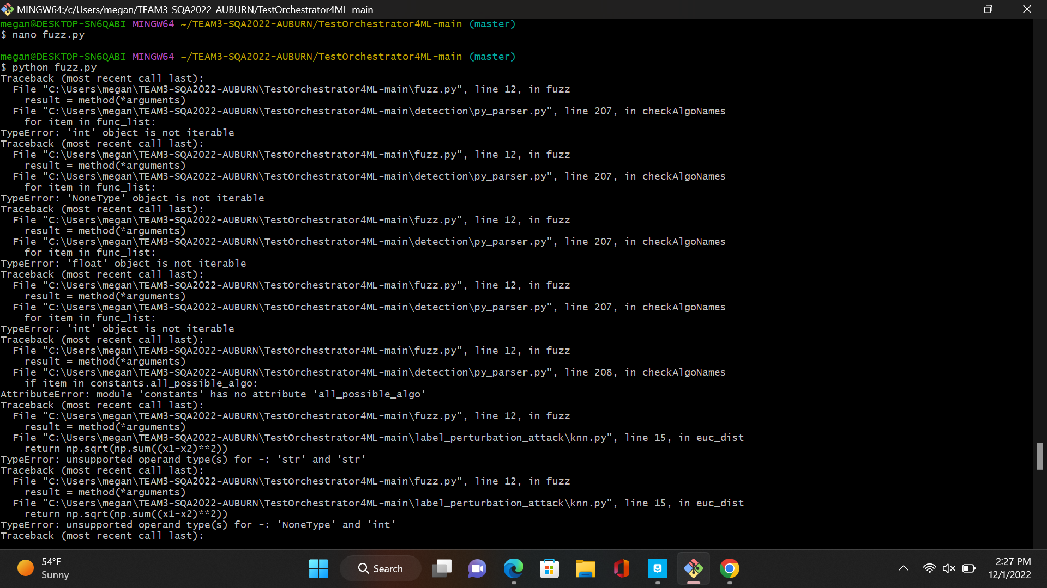

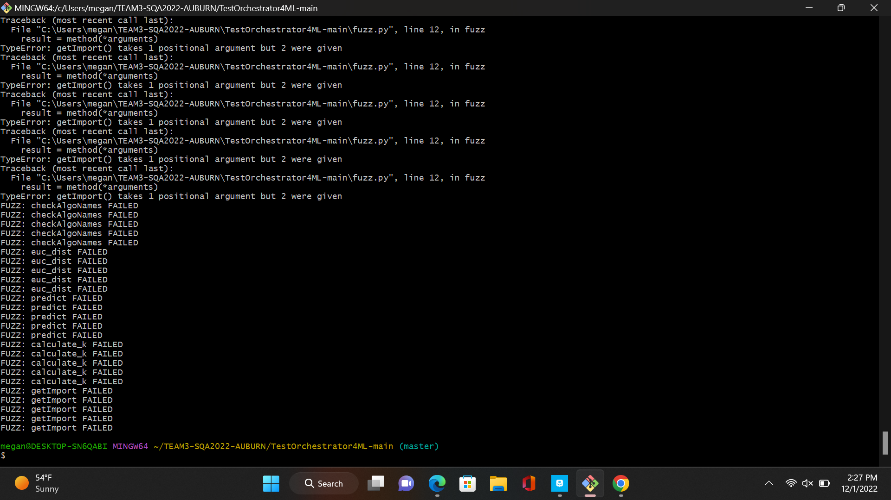

Below shows that it was ran successfully within GitHub Actions.

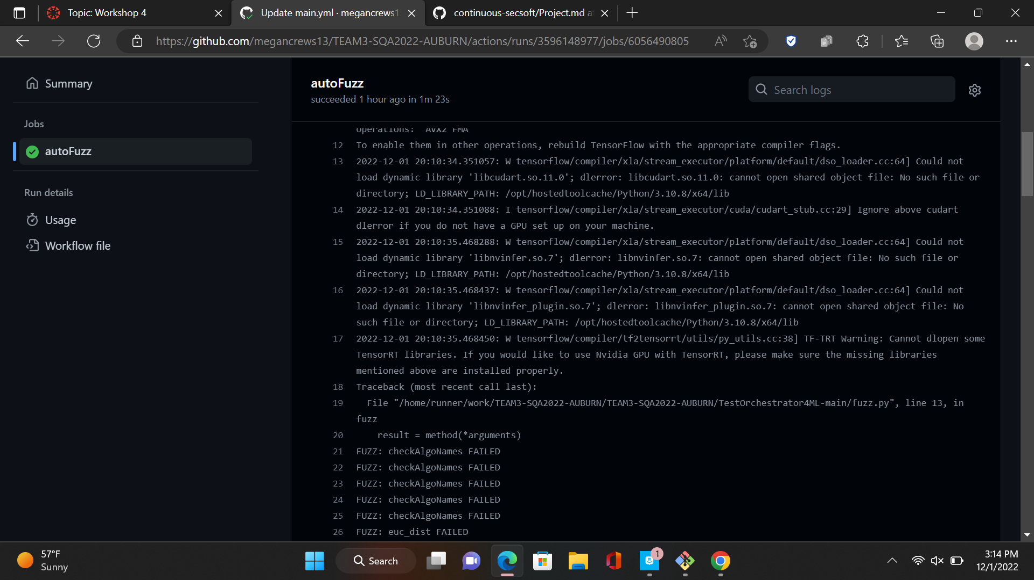

**4c. Forensics (Will Thompson)**

Logging has been added to five methods providing information on the running method:

1. generation/main.py/generateUnitTest
2. generation/main.py/generateAttack
3. label_perturbation_attack/main.py/run_experiment
4. label_perturbation_attack/main.py/repeat_experiment
5. label_perturbation_attack/main.py/main

Below is an expert of the log:

